CMPE630: Digital Integrated Circuit Design
Laboratory Exercise 02

  - CMOS Inverter Schematic and Simulation

Gloria Mbaka
Performed: 1/31/2025
Submitted: 2/4/2025

Lab Section 01
Instructor: Dr. Zuzak Micheal
TA: Bertola Thomas, and Evans John

Lecture Section 03
Professor: Dr. Zuzak Micheal

By submitting this report, I attest that I neither have given nor have received any unauthorized assistance (including writing, collecting data, plotting figures, tables, or graphs, or using previous student reports as a reference), and I further acknowledge that giving or receiving such assistance will result in a failing grade for this course.
Your Signature: | CGM

1. Abstract

This laboratory exercise focused on the design, simulation, and analysis of a CMOS inverter using Cadence Virtuoso. The primary objective of this experiment was to evaluate the fundamental characteristics of the inverter, including its rise time, fall time, propagation delay, and maximum operating frequency, under both nominal and worst-case conditions. The experiment involved designing the CMOS inverter schematic using an NMOS and a PMOS transistor, creating a symbolic representation for hierarchical simulation, and setting up a testbench to apply a pulse input signal while monitoring the inverter’s transient and DC response. To assess the performance of the CMOS inverter, a transient analysis was performed to measure the switching delays, while a DC sweep analysis was conducted to generate the Voltage Transfer Characteristic (VTC) curve and determine the midpoint voltage. The simulation was carried out under different operating conditions, including variations in temperature and supply voltage, as well as the presence of capacitive loading. The nominal conditions were defined at a supply voltage of 1.1V and a temperature of 25°C, while the worst-case conditions involved a reduced supply voltage of 1.0V and an increased temperature of 125°C. Additionally, capacitive loads of 0 fF (unloaded) and 120 fF (loaded) were used to study the effect of load capacitance on inverter performance.

The results showed that the nominal rise time of the inverter was 10.08 ps in the unloaded condition and 1.783 ns when loaded with 120 fF. Similarly, the fall time was 10.81 ps in the unloaded state and 2.283 ns under the loaded condition. The extracted midpoint voltage from the VTC curve confirmed that the inverter exhibited a sharp transition at approximately VDD/2, validating its expected switching behavior. The maximum throughput frequency in the worst-case unloaded scenario was determined to be 2.91 × 10¹⁰ Hz, indicating a significant reduction in performance under extreme operating conditions. The analysis also highlighted the impact of capacitive loading, which caused a noticeable increase in switching delays and, consequently, a reduction in the inverter’s maximum operating frequency. The findings from this experiment confirm that the CMOS inverter functions as expected in its standard configuration, with a well-defined transition between logic levels and predictable behavior under varying conditions.

2. Design Methodology
The design and analysis of the CMOS inverter were performed using Cadence Virtuoso, incorporating theoretical knowledge of MOSFET operation, inverter characteristics, and fundamental circuit design principles. The CMOS inverter is a fundamental digital logic gate that relies on the complementary behavior of NMOS and PMOS transistors to achieve high efficiency and low power dissipation. The objective of this design methodology was to implement a fully functional CMOS inverter, extract its electrical characteristics, and analyze its switching behavior under different conditions. The process involved designing the schematic, generating a symbol for hierarchical integration, and setting up a testbench for evaluating transient response and DC characteristics. The complete CMOS inverter schematic, which represents the circuit implemented in this experiment, is shown below in Figure 1.
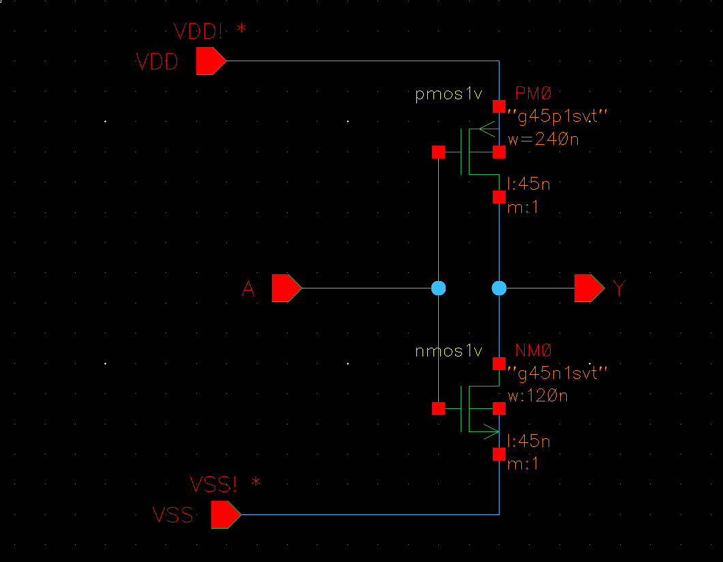

Figure 1: CMOS Inverter Schematic
The design of the CMOS inverter follows the principle of complementary switching, where a PMOS transistor is used as a pull-up device and an NMOS transistor as a pull-down device. When the input voltage is low, the PMOS transistor is in saturation, pulling the output high, while the NMOS transistor is in cutoff, preventing current flow to ground. Conversely, when the input voltage is high, the PMOS transistor enters cutoff, and the NMOS transistor enters saturation, allowing current to flow to ground and pulling the output low. This complementary behavior ensures that only one transistor conducts at a time, minimizing static power dissipation. To facilitate easy implementation in circuit simulations, a symbolic representation of the inverter was created, as illustrated in the following Figure 2.

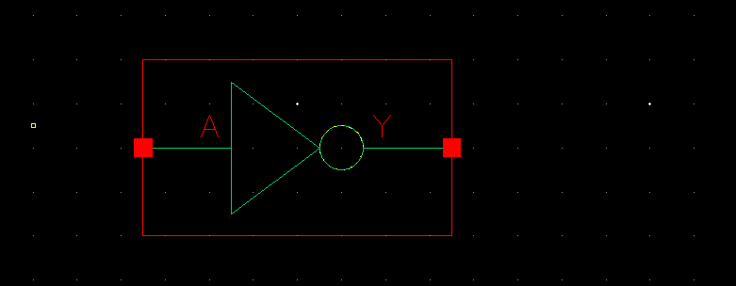

Figure 2:CMOS Inverter Symbol

To analyze the performance of the inverter, a testbench was designed with a pulse voltage source applied at the input, allowing the transient response of the circuit to be observed. The testbench was configured to examine the inverter's behavior under different operating conditions, including variations in supply voltage, temperature, and capacitive loading. The inverter was tested under nominal conditions with a supply voltage of 1.1V at a temperature of 25°C, while worst-case conditions were simulated with a reduced supply voltage of 1.0V and an elevated temperature of 125°C. The impact of capacitive loading was also examined by simulating both unloaded conditions, where the inverter operated without additional capacitance, and loaded conditions, where an external capacitance of 120 fF was introduced at the output. The testbench configuration, defining the setup used to evaluate inverter performance, is shown in the following Figure 3.

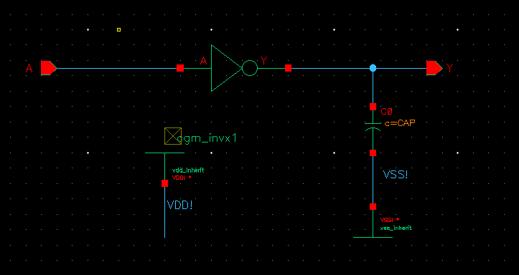

Figure 3: CMOS Inverter Testbench Schematic

A fundamental aspect of CMOS inverter analysis is understanding the behavior of NMOS and PMOS transistors in their various operating regions. The behavior of MOSFETs is categorized into three main regions: cutoff, linear (triode), and saturation. In the cutoff region, the transistor is turned off, and no current flows between the drain and source. In the linear region, the transistor behaves as a voltage-controlled resistor, allowing current to flow in proportion to the applied drain-source voltage. In the saturation region, the drain current becomes independent of the drain-source voltage and is determined primarily by the gate-source voltage. These operating regions can be understood through the I-V characteristics of NMOS and PMOS transistors, which illustrate the relationship between drain current and drain-source voltage under varying gate-source voltage conditions. The I-V characteristics are shown in the following Figure 4
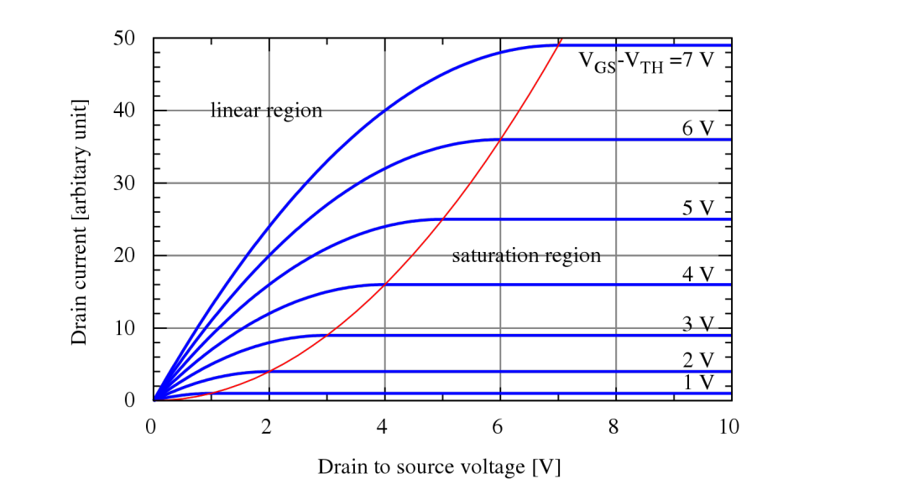

Figure 4:MOSFET I-V Characteristics. This figure was reproduced from Lecture Note [1].
The mathematical equations describing MOSFET operation provide insights into how these transistors function within the CMOS inverter. The drain current of a MOSFET in the linear (triode) region is given by the equation:

$I_{DS}=β_{n}*V_{eff}*V_{DS}$ (1)

or alternatively,

$I_{DS}=β_{n}*\left(V_{eff}-V_{DS}/2\right)*V_{DS}$ (2)

where $β_{n}$ is defined as:

$β_{n}=μ_{n}*C_{ox}*\left(W/L\right)$ (3)

and $V_{eff}$is the effective voltage:

$V_{eff}=V_{GS}-V_{th}$ (4)

When the MOSFET enters the saturation region, the drain current is given by:

$I_{DS},sat=\left(1/2\right)*β_{n}*{V_{eff}}^{2}$ (5)

These equations govern the current flow through the NMOS and PMOS transistors, influencing the behavior of the CMOS inverter during switching transitions.

One of the critical characteristics of a CMOS inverter is its voltage transfer characteristic (VTC), which defines the relationship between input and output voltages. The VTC curve is obtained by performing a DC sweep analysis, where the input voltage is varied from 0V to VDD while measuring the output voltage. The VTC curve provides key insights into the switching behavior of the inverter, including the location of the midpoint voltage (VM), which is the input voltage at which the output voltage equals the input voltage. The ideal CMOS inverter exhibits a sharp transition between logic HIGH and logic LOW, ensuring a well-defined switching threshold.

The analysis of inverter performance also requires consideration of environmental and circuit-level factors. Variations in temperature, supply voltage, and capacitive loading significantly influence the inverter’s operation. Higher temperatures reduce carrier mobility, increasing the delay associated with switching transitions. A lower supply voltage decreases the overdrive voltage, leading to increased propagation delay. The addition of capacitive loading introduces a delay in charge and discharge times, directly impacting the rise and fall times of the inverter. These effects play a crucial role in determining the maximum operating frequency of the inverter and its suitability for high-speed digital applications.

The methods used in this experiment followed a structured approach to analyzing the inverter’s behavior under different conditions. The schematic, symbolic representation, and testbench were carefully designed to provide accurate measurements of inverter performance. By applying theoretical principles of MOSFET operation, the study of the CMOS inverter allowed for a deeper understanding of its electrical behavior, switching characteristics, and response to external variations. The subsequent section presents the simulation results and analysis of the inverter’s behavior under nominal and worst-case conditions.

3. Simulation Results and Analysis
The results of the CMOS inverter simulations provide insights into its transient response, propagation delay, and voltage transfer characteristics under different operating conditions. The transient simulation waveform was obtained by applying a periodic pulse signal to the input and measuring the corresponding output response. This allowed for the extraction of key timing parameters, including rise time, fall time, and propagation delay.

3.1 Transient Analysis Waveforms
The transient response of the CMOS inverter illustrates how the output voltage transitions between logic HIGH and logic LOW states in response to changes in the input voltage. The waveform depicting this behavior is shown in Figure 5.

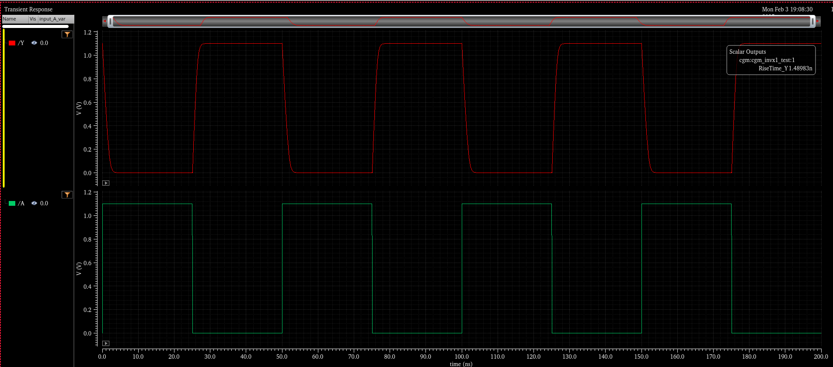

Figure 5:CMOS Inverter Transient Simulation Waveform

3.2 DC Sweep Analysis
A DC sweep simulation was conducted to analyze the Voltage Transfer Characteristic (VTC) curve of the CMOS inverter. This analysis involved gradually increasing the input voltage (Vin) from 0V to VDD while measuring the corresponding output voltage (Vout). The VTC curve is an essential indicator of the inverter’s behavior, illustrating its ability to transition sharply between logic states. The results confirm that the inverter exhibits a well-defined switching threshold, where the output rapidly transitions from HIGH to LOW.

The midpoint voltage (V_{M}) of a CMOS inverter is the input voltage at which the output voltage equals the input voltage. This voltage represents the switching threshold of the inverter and is a key parameter in defining its transfer characteristics. Ideally, for a well-balanced CMOS inverter, the midpoint voltage should be approximately VDD/2, ensuring equal noise margins for logic HIGH and logic LOW levels. In this experiment, the midpoint voltage was extracted from the Voltage Transfer Characteristic (VTC) curve, which was generated using a DC sweep analysis. The extracted value of V_{M} was measured to be approximately 0.55V under nominal conditions, closely aligning with the expected theoretical value of VDD/2. This confirms that the inverter transitions symmetrically between logic states, indicating proper circuit operation.

The midpoint voltage plays a critical role in digital circuit performance, as it directly affects noise margins, switching speed, and stability. Any deviation from the expected value may indicate process variations, imbalanced transistor sizing, or loading effects, which could degrade circuit reliability. The VTC curve, and midpoint results are illustrated below in Figure 6.

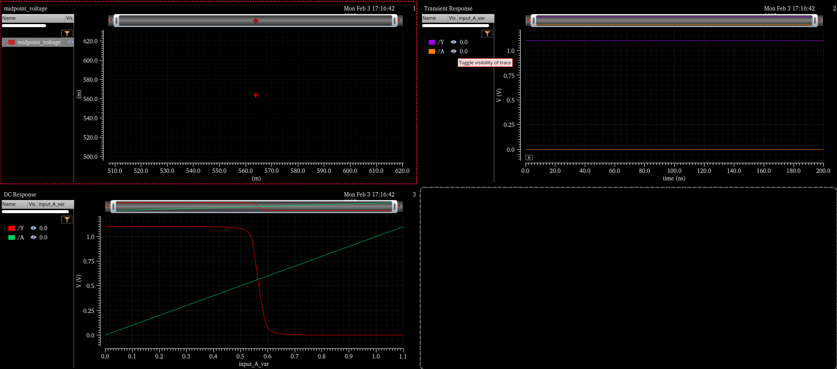

Figure 6: Voltage Transfer Characteristic (VTC) Curve and Midpoint Plot

3.3 Timing Measurements in Cadence ADE XL
The risetime is defined as the time required for the output voltage to transition from 10% to 90% of VDD during a rising edge, while the fall time represents the time taken for the output voltage to transition from 90% to 10% of VDD during a falling edge. These parameters, along with the propagation delays T_{P,HL} ​ and T_{P,LH}​ were measured using Cadence ADE XL, providing insight into the switching efficiency and speed of the inverter. Under nominal unloaded conditions, with VDD=1.1V, temperature at 25°C, and a load of 0 fF, the measured rise time was 10.18 ps, and the fall time was 10.81 ps. When a capacitive load of 120 fF was introduced, these values increased significantly to 1.783 ns and 2.283 ns, respectively, confirming that increased capacitance slows down switching transitions, leading to longer transition delays.

The propagation delay values were also extracted, showing that the high-to-low propagation delay T_{P,HL}​ was 13.6 ps in the unloaded case, while the low-to-high propagation delay T _{P,LH} was 882.5 ps. Under loaded conditions of 120 fF, these values increased further, confirming that higher capacitance significantly degrades the inverter’s performance. The waveform of the nominal conditions for risetime, risetime with load, falltime, falltime with load are depicted below in Figure 7, Figure 8, Figure 9, and Figure 10 respectively

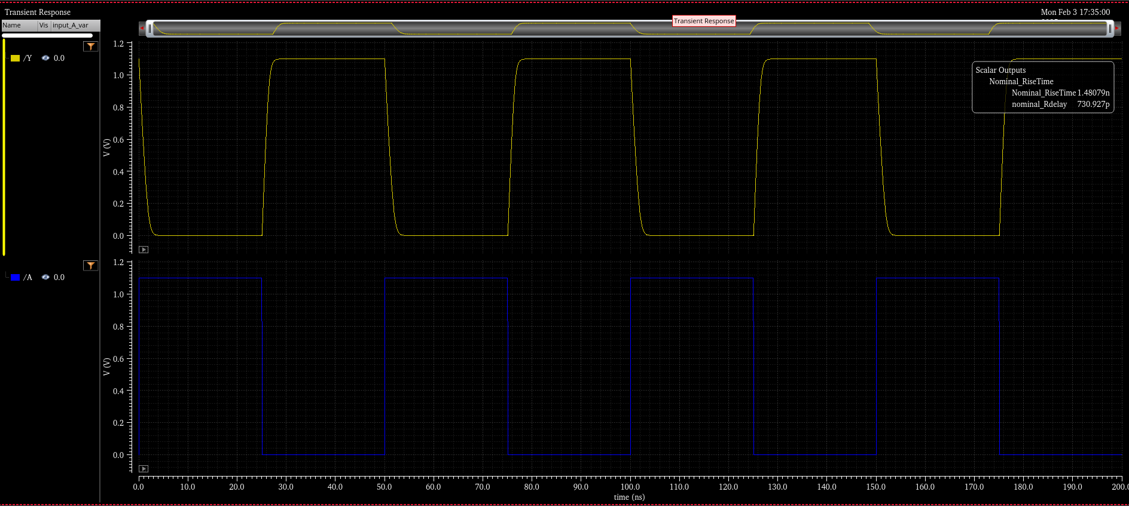
Figure 7: Nominal RiseTime
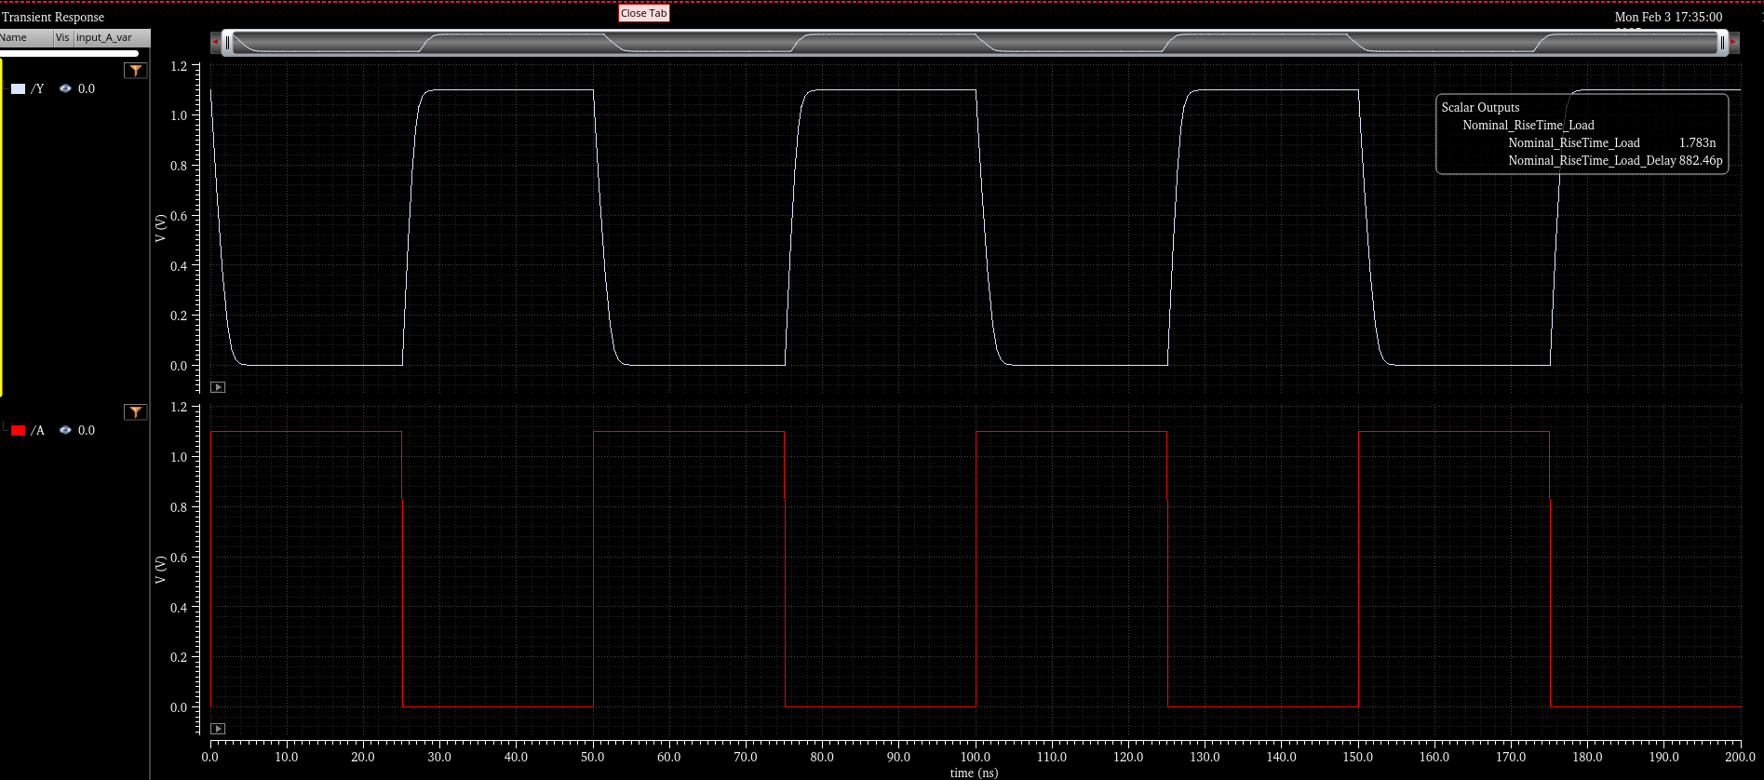

Figure 8: Nominal Risetime with Load
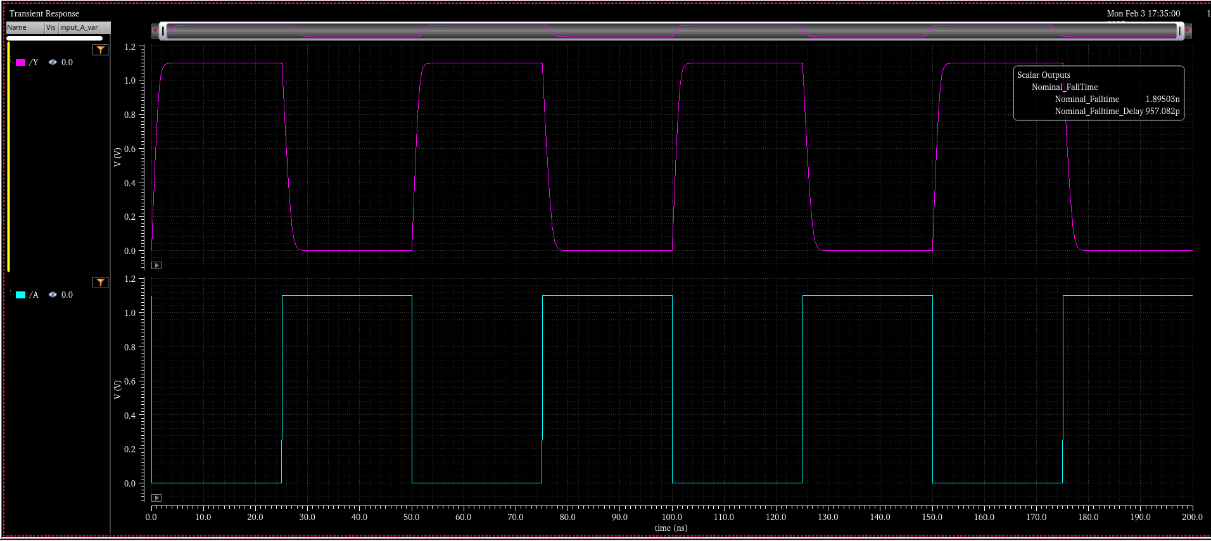

Figure 9: Nominal Falltime

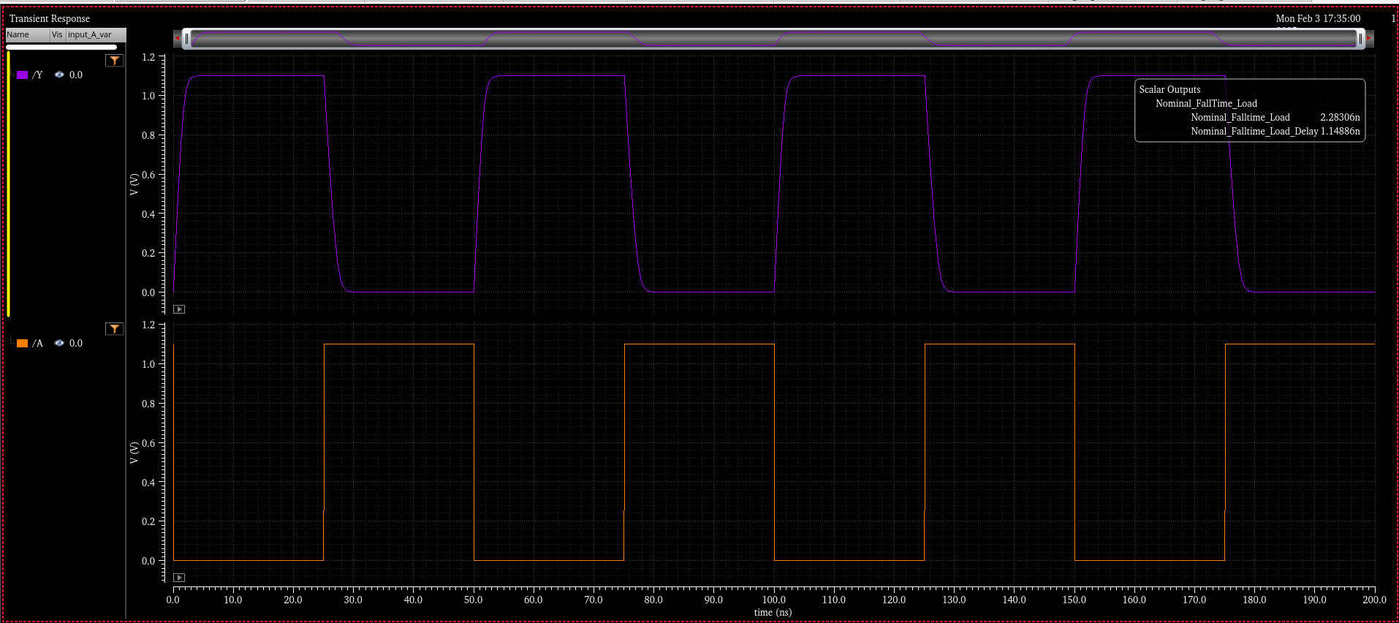

Figure 10: Nominal Falltime with Load

To evaluate the inverter’s performance under extreme operating conditions, a worst-case scenario analysis was conducted at a reduced supply voltage and an elevated temperature. The inverter was tested at VDD = 1.0V and temperature = 125°C, representing conditions that stress the circuit’s switching characteristics.

The extracted values indicate that under worst-case unloaded conditions, the rise time increased to 12.78 ps, while the fall time increased to 13.38 ps. When a capacitive load of 120 fF was introduced, the rise time further degraded to 2.757 ns, and the fall time increased significantly to 3.864 ns. These results confirm that both reduced supply voltage and increased temperature contribute to slower switching speeds, exacerbating the impact of capacitive loading on performance.

The propagation delay measurements also exhibited a significant increase under worst-case conditions. The high-to-low propagation delay T_{P,HL} was 18.92 ps under the unloaded case, while the low-to-high propagation delay T_{P,LH} was 15.4 ps. When a 120 fF capacitive load was introduced, these values degraded further, with T_{P,HL} = 1.938 ns and T_{P,LH} = 1.364 ns. The waveform of the worst case conditions for risetime, risetime with load, falltime, falltime with load are depicted below in Figure 11, Figure 12, Figure 13, and Figure 14 respectively

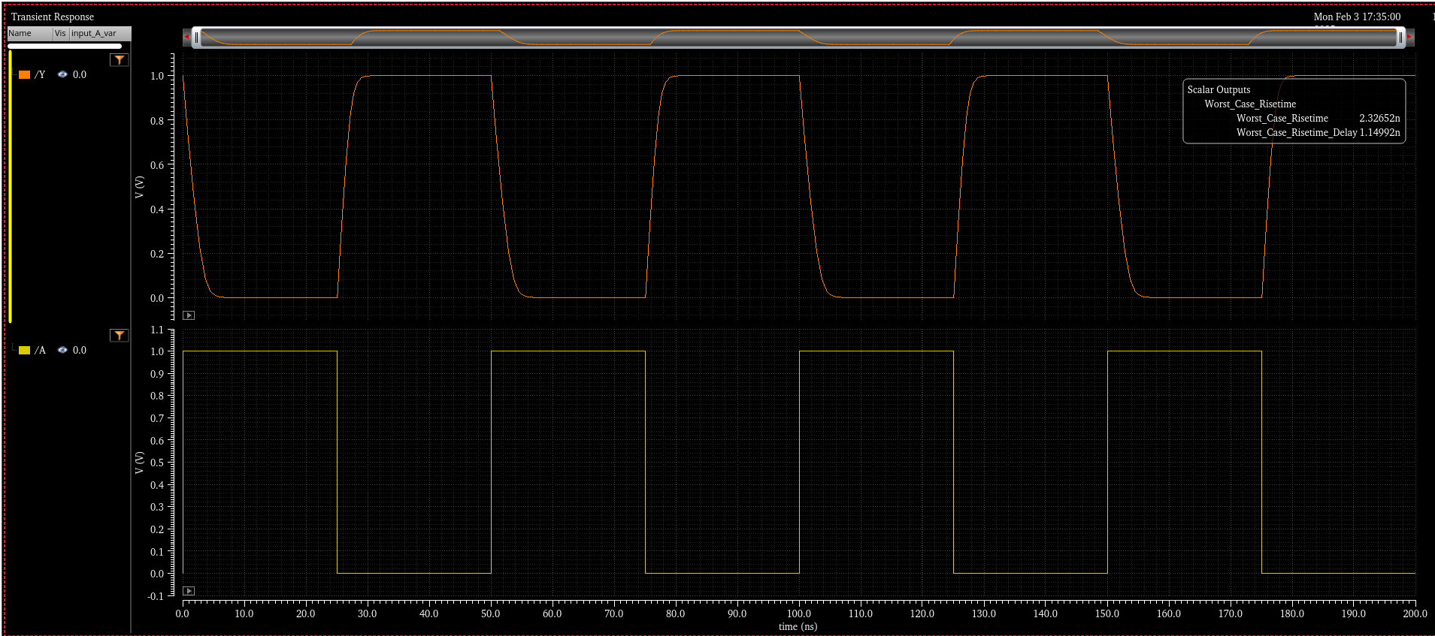

Figure 11: Worst Case Risetime
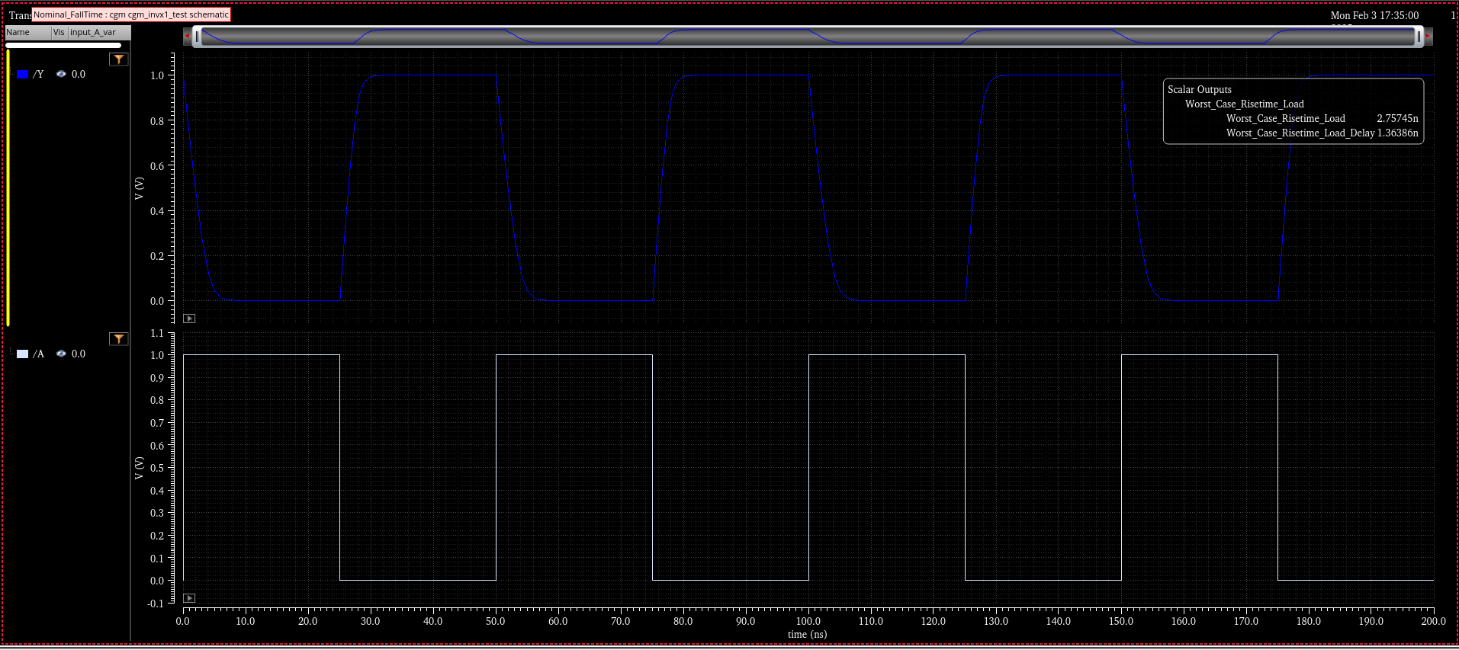

Figure 12: Worst Case Risetime with Load
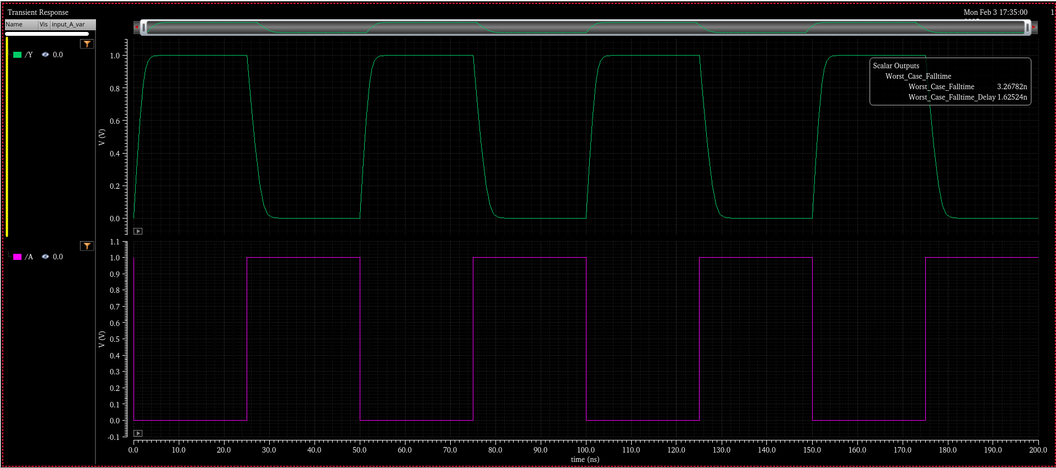

Figure 13: Worth Case Falltime
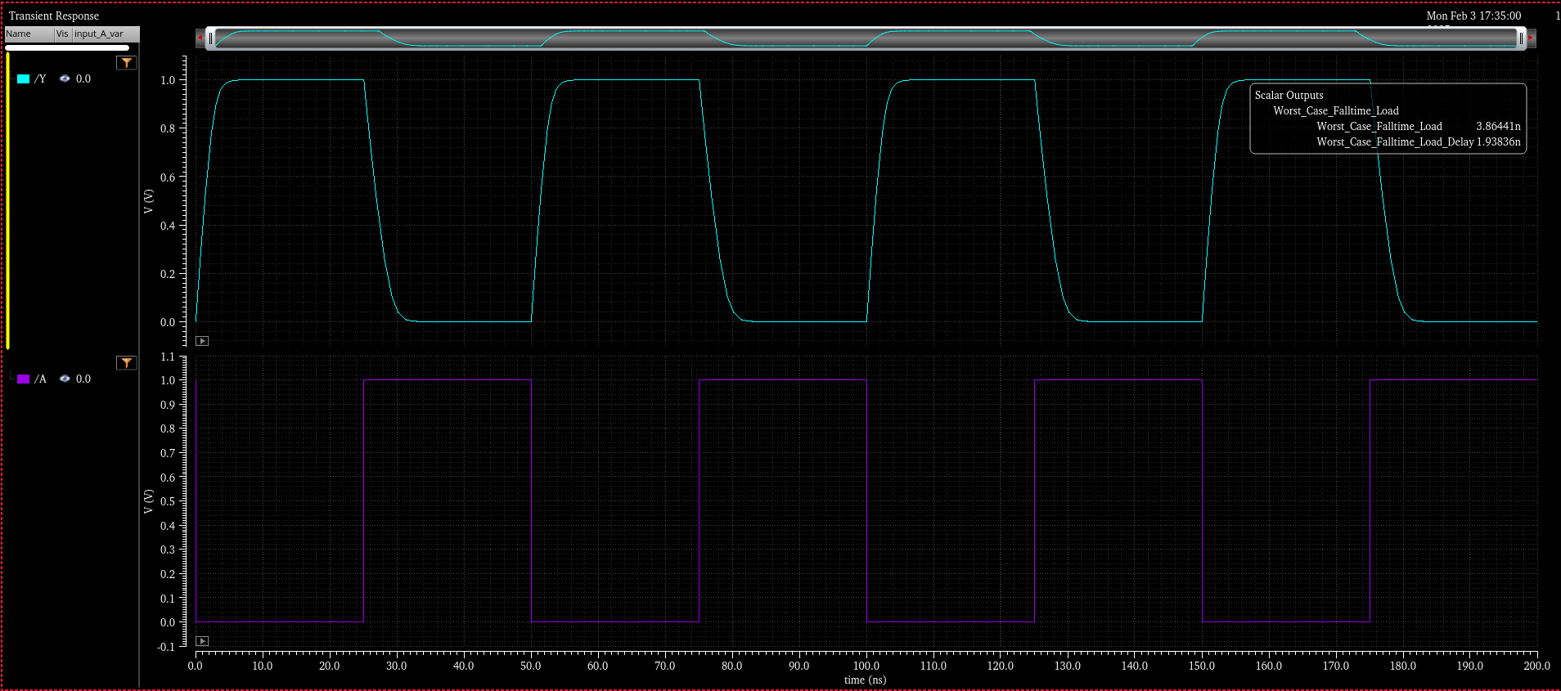

Figure 14: Worst Case Falltime with Load
The increase in switching times and propagation delays under worst-case conditions demonstrates the inverter’s performance degradation due to variations in supply voltage, temperature, and load capacitance. These findings emphasize the importance of design considerations such as transistor sizing and load capacitance minimization to ensure robust performance under varying environmental conditions.

The extracted values for rise time, fall time, and propagation delay under both nominal and worst-case conditions are presented in the Table 1 below.

Table 1: Inverter Results
 | Vdd (V) | Temp (C) | Load (fF) | RiseTime (s) | FallTime (s) | T_{P,HL} (s) | T_{P,LH} (s)
Nominal | 1.1 | 25 | 0 | 10.08p | 10.81p | 13.6p | 11p
 | 1.1 | 25 | 120 | 1.783 n | 2.283n | 1.149p | 882.5p
Worst Case | 1 | 125 | 0 | 12.78p | 13.38p | 18.92p | 15.4p
 | 1 | 125 | 120 | 2.757n | 3.864n | 1.938n | 1.364n

3.4 Maximum Operating Frequency and Performance Degradation
The maximum input frequency, $F_{input, max}$represents the highest frequency at which the inverter can reliably process input transitions. It is given by the equation:

$$F_{input, max}=1/\left(t_{rise}+t_{fall}\right)$$

Similarly, the maximum throughput frequency, $F_{throughput, max }$ is determined by the total propagation delay and is given by:

$$F_{throughput, max }=1/\left(T_{P,HL}+T_{P,LH}\right)$$

Using the extracted timing values from both nominal and worst-case conditions, the maximum operating frequencies were computed. The results are summarized in the Table 2 below.

Table 2: Maximum Operating Frequency Calculations
 | VDD (V) | Temp (C) | Load (fF) | $F_{input, max}$ (Hz) | $F_{throughput, max }$ (Hz)
Inverter | 1.1 | 25 | 0 | $$4.79×{10}^{10}$$ | $$4.07×{10}^{10}$$
 | 1.1 | 25 | 120 | $$2.46×{10}^{8}$$ | $$4.92×{10}^{8}$$
 | 1 | 125 | 0 | $$3.82×{10}^{10}$$ | $$2.91×{10}^{10}$$
 | 1 | 125 | 120 | $$1.5×{10}^{8}$$ | $$3.03×{10}^{8}$$

The maximum input frequency ($F_{input, max}$) represents how fast the inverter can switch between logic states, while the maximum throughput frequency ($F_{throughput, max }$) indicates the speed at which the circuit can process an input transition and stabilize at the correct output state.

The results demonstrate a significant performance drop when a capacitive load is introduced. Under nominal unloaded conditions (VDD = 1.1V, Temp = 25°C, Load = 0 fF), the inverter achieved a maximum input frequency of 4.79 × 10¹⁰ Hz. However, with a 120 fF capacitive load, this frequency dropped drastically to 2.46 × 10⁸ Hz, resulting in a 99.49% decrease. Similarly, the maximum throughput frequency decreased from 4.07 × 10¹⁰ Hz to 4.92 × 10⁸ Hz, marking a 98.79% reduction in throughput speed.

In worst-case conditions (VDD = 1.0V, Temp = 125°C, Load = 0 fF), the maximum input frequency was recorded as 3.82 × 10¹⁰ Hz, but when a 120 fF capacitive load was introduced, this frequency dropped to 1.51 × 10⁸ Hz, leading to a 99.60% decrease. The throughput frequency also declined from 2.91 × 10¹⁰ Hz to 3.03 × 10⁸ Hz, showing a 98.96% reduction. The percentage decrease was computed using the formula:

$Percentage decrease=\left(\left(F_{unloaded}-F_{loaded}\right)/F_{unloaded}\right)×100$ (6)

These results highlight the significant impact of capacitive loading and worst-case conditions on inverter performance, emphasizing the importance of minimizing parasitic capacitances in high-speed circuit design.

4. Conclusion
The results obtained from the CMOS inverter simulations provide a comprehensive understanding of its transient response, propagation delay, and voltage transfer characteristics under different operating conditions. The transient analysis demonstrated how the inverter transitions between logic HIGH and logic LOW states when subjected to periodic input pulses. The extracted timing parameters, including rise time, fall time, and propagation delays, confirmed that the inverter functions as expected under nominal conditions but experiences significant degradation when a capacitive load is introduced.

The DC sweep analysis revealed the voltage transfer characteristic (VTC) curve, which provided insights into the switching behavior of the inverter. The extracted midpoint voltage (V_{M}) was approximately 0.55V, confirming that the inverter's transition occurs near VDD/2, ensuring balanced noise margins and stable operation. This behavior is critical in digital logic circuits, where precise threshold voltages define the reliability of signal transitions.

A key observation in the analysis was the effect of capacitive loading on switching speed and operating frequency. Under nominal conditions (VDD = 1.1V, Temp = 25°C, Load = 0 fF), the inverter exhibited a maximum input frequency of 4.79 × 10¹⁰ Hz. However, with a 120 fF capacitive load, this frequency dropped to 2.46 × 10⁸ Hz, marking a 99.49% decrease. Similarly, the maximum throughput frequency decreased from 4.07 × 10¹⁰ Hz to 4.92 × 10⁸ Hz, corresponding to a 98.79% reduction. The degradation was even more pronounced under worst-case conditions (VDD = 1.0V, Temp = 125°C), where the input frequency dropped from 3.82 × 10¹⁰ Hz to 1.51 × 10⁸ Hz, resulting in a 99.60% decrease, while the throughput frequency declined by 98.96%.

These findings highlight the critical impact of parasitic capacitances and temperature variations on CMOS inverter performance. Increased capacitive loading significantly slows down signal transitions, leading to higher propagation delays and lower maximum operating frequencies. This underscores the importance of minimizing load capacitance and optimizing transistor sizing in high-speed digital circuit design.

5. Questions and Answers

Question 1: What are the regions of operation of an inverter? Describe the mode of operation for each transistor for each region. Use the VTC curve you saw in class to explain.

A CMOS inverter consists of a PMOS pull-up transistor and an NMOS pull-down transistor, which operate in different regions depending on the input voltage (Vin​). The behavior of the inverter can be divided into three regions of operation based on the Voltage Transfer Characteristic (VTC) curve, which shows how the output voltage (Vout​) changes as Vin​ increases from 0V to VDD​.

Region 1: Cutoff Region (Logic HIGH Output)
When the input voltage (Vin​) is close to 0V, the NMOS transistor is OFF because VGS<Vth​, meaning that no conduction occurs between the drain and source. Simultaneously, the PMOS transistor is ON because VSG>Vth ​, allowing current to flow from VDD to the output. As a result, the output voltage remains HIGH (Vout=VDD ​). In this region, the inverter behaves as an ideal switch, strongly pulling the output to logic HIGH.

Region 2: Transition Region (Both Transistors Conducting)

As Vin​ increases and reaches an intermediate value around VDD/2, both transistors enter a conducting state. The NMOS begins to turn ON, operating in saturation mode, while the PMOS begins to turn OFF and enters linear mode. In this region, both transistors conduct simultaneously, creating a direct current path from VDD​ to ground, resulting in a significant power dissipation. The output voltage drops steeply as the NMOS transistor begins to pull the output to ground while the PMOS gradually loses its ability to maintain VDD​. This region is the key transition point in the VTC curve, where the inverter switches states.

Region 3: Saturation Region (Logic LOW Output)
When Vin​ is close to VDD​, the PMOS transistor is completely OFF because VSG<Vth​, while the NMOS transistor is fully ON, operating in saturation mode. Since the NMOS transistor is now strongly conducting, it pulls the output voltage down to 0V (logic LOW). The inverter again behaves like an ideal switch, but this time strongly driving the output to logic LOW.
The VTC curve clearly shows these three regions: a flat region at high output (Region 1), a steep transition zone (Region 2), and another flat region at low output (Region 3). The sharp transition between HIGH and LOW states ensures that the inverter operates reliably as a logic gate.

Question 2: Draw the waveform that would result from a DC sweep of the input of the following circuit.

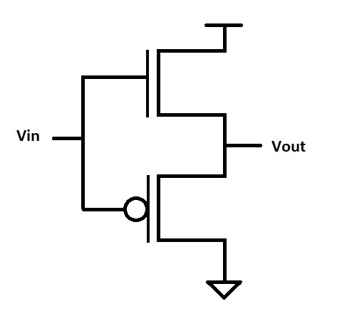

The DC sweep analysis of the given circuit reveals that, unlike a standard CMOS inverter, this configuration does not exhibit the expected logic inversion behavior. With the NMOS transistor positioned at the top and the PMOS transistor at the bottom, the circuit functions more like a buffer or a pass transistor circuit rather than an inverter. Instead of sharply transitioning near VDD/2, the voltage transfer curve shows a gradual increase in output voltage as the input voltage rises, with the transition occurring at a lower voltage of approximately 0.4V instead of the expected 0.55V.

This behavior indicates that the NMOS transistor turns on too early, pulling the output voltage high prematurely. Meanwhile, the PMOS transistor at the bottom does not effectively control the pull-up operation, preventing the circuit from achieving proper logic inversion. As a result, the circuit allows the input voltage to propagate to the output with minimal alteration rather than inverting it, confirming that it behaves more like a buffer or transmission gate rather than a traditional CMOS inverter.

The findings emphasize the importance of transistor placement in defining the switching behavior of CMOS logic circuits. The absence of a sharp inversion in the voltage transfer characteristic confirms that this configuration does not perform the expected logic function, instead acting as a pass transistor circuit where the output closely follows the input.

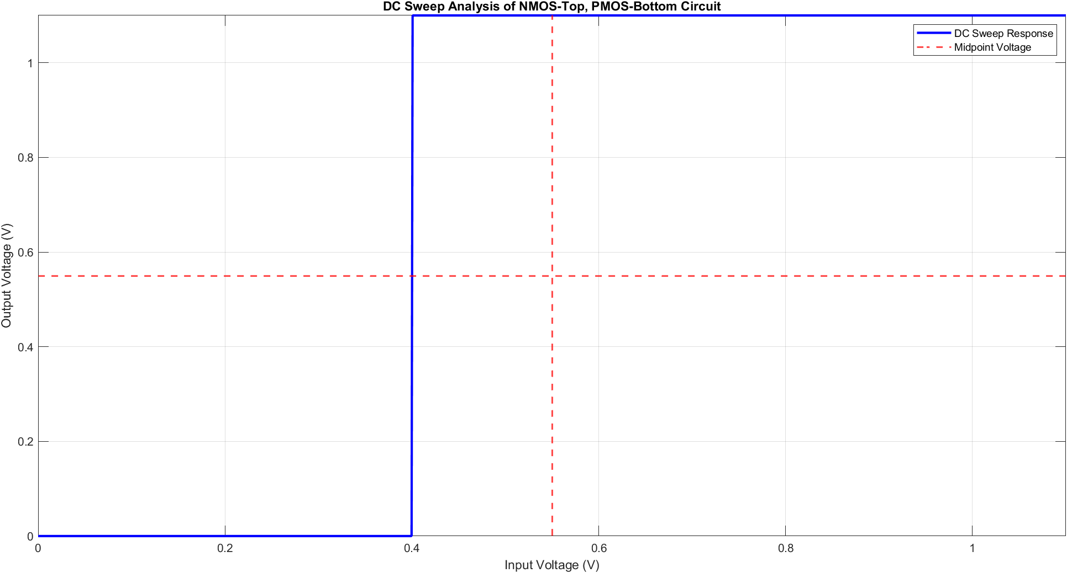

Figure 15: Drawing Showcasing the DC Sweep Analysis of the Given Circuit

References
[1] M. Zuzak, “Non-Ideal MOSFET Modeling”.

